**Dosimetric Evaluation of Terrestrial Gamma Radiation and Associated Cancer Risk in Federal University Dutsin-Ma, Nigeria**

Namadi A.Z1, Agu M.N2 and Ugbe R.U3

1Physics Department, Faculty of Physical Sciences, Federal University Dutsin-Ma

2Physics Department, Faculty of Science, Nigerian Defence Academy, Kaduna

3Groundwater Department, National Water Resources Institute, Kaduna.

**Abstract**

*This study evaluates natural radioactivity on FUDMA campuses to ensure radiological safety. Since natural radionuclides are always present in the environment, exposure to terrestrial gamma radiation is unavoidable. The research aimed to measure terrestrial gamma radiation dose rates (TGDR), calculate the annual effective dose (AED), and assess the excess lifetime cancer risk (ELCR). A digital radiation meter was used for measurements, while Microsoft Excel was used for data analysis. At the take-off campus, The highest AED was recorded at the school clinic (TOC-A5) with a value of 2.76 mSv/y, while the lowest was at the school gate (TOC-A1) at 1.02 mSv/y. The average AED across the campus was 1.75 mSv/y. At the main campus, the highest AED was 2.64 mSv/y at the school clinic (MC-A4), and the lowest was 1.14 mSv/y at the Senate Building (MC-A2), with an average of 1.64 mSv/y. These values exceed the ICRP (2007) recommended limit of 1 mSv/y for the general public, indicating potential health risks. For ELCR, the take-off campus recorded the highest value at the school clinic (TOC-A5) with 8.68, while the lowest was at the school gate (TOC-A1) with 3.21, averaging 5.49. At the main campus, the highest ELCR was 8.30 at the school clinic (MC-A4), and the lowest was 3.59 at the Senate Building (MC-A2), with an average of 4.99. These results suggest an increased radiological risk compared to standard safety limits.*

**Key words:** AED, ELCR, FUDMA and TGRD.

Corresponding Author: [nabdulrahman@fudutsinma.edu.ng](mailto:nabdulrahman@fudutsinma.edu.ng) +2348037874055

**INTRODUCTION**

Radionuclides are present naturally in the earth’s crust (Pöschl and Nollet, 2007). They are found on the earth’s surface, in the soil, the atmosphere, water, building materials, and in plant and animal tissue (UNSCEAR, 2000). All living organisms including human beings are exposed to different radioactive sources that is subject to the surroundings thereof (Ochiai, 2014; Jaishankar, *et al*., 2014). Due to natural evolution, all living organisms have adapted to certain amounts of radioactivity without suffering any harmful effects (Kovalchuk *et al*., 2001). A major concern arises when certain human activities such as testing of nuclear weapons, mineral exploration, and agriculture significantly enhance exposures of humans and the environment to alarming levels of radioactivity (Ahmed and El-Arabi 2005). Terrestrial gamma radiation dose is a measure of the level of [ionizing radiation](https://en.wikipedia.org/wiki/Ionizing_radiation) present in the environment at a particular location which is not due to deliberate introduction of radiation sources. Terrestrial gamma radiation originates from both natural and artificial sources. (IAEA, 2007). Radiation in the environment originates from a number of naturally occurring and human‑made sources while exposure from it can occur via ingestion, inhalation, injection, or absorption of radioactive materials (Abba, 2022). The effects of terrestrial gamma radiation dose on human health depend on the level of exposure. Prolonged exposure to elevated levels of ionizing radiation can have health effects, including: increased cancer risk, genetic damage, acute radiation sickness and cataracts. Terrestrial gamma radiation dose can affect plant growth and cause genetic mutations, population dynamics, radiosensitivity, bioaccumulation and behavioural changes. The aim of this work is to measure and statistically analyse excess life cancer risk due to terrestrial gamma radiation doses (TGRD) and compute the resultant effective doses in the Federal University Dutsin-Ma campuses, Katsina state, Nigeria. In addition, it will be of great importance to assess the safety levels by comparing the obtained results with the permissible limits set by (WHO, 2003), (USEPA, 2011), (ICRP, 2007) and (UNSCEAR, 2000) ensuring compliance with international safety standards.We live in an environment where we are being exposed to certain amounts of ambient radiation every day, this ambient radiation may be from natural sources (e.g. radon gas, soil, granite rocks) or artificial sources (e.g. x-ray machines, building materials, radioactive wastes from reactors, etc.) in the environment and the level of radiation varies from one place to another (Tikyaa *et al*., 2017; Farai and Vincent, 2006). Aliyu et al. (2023) analyzed uranium and thorium contamination in baobab leaves consumed in Katsina State, Nigeria, and found that the activity concentrations were within safe limits. Radon gas from the earth crust is the most abundant source of natural radiation in the environment. The radioactive disintegration of uranium-238 produces 222Rn which in turn decays with a half-life of 3.82 days (Tikyaa *et al*., 2017; Masok *et al.*, 2015). As it is inhaled, it penetrates into the lungs and the continuous deposition and penetration of such high energy particles through the lungs leads to tissue damage and mutation which leads to incidence of lung cancer (Tikyaa *et al*., 2017; Chad-Umoren *et al.*, 2007). Other natural radiation sources include radionuclides in the soil, cosmic radiation due to ionization of gases in the atmosphere and natural radioactivity due to radionuclides in the body (Tikyaa *et al*., 2017; Osiga, 2014 and James *et al.,* 2015). The materials used in constructing buildings are also major sources of indoor radiation exposure to humans while in the soil, natural radioactivity is mainly due to 238U, 40K, 226Ra which causes external and internal radiological hazard from consumption of crops grown on such (UNSCEAR, 2021). Generally, ionizing radiation when absorbed at higher doses poses health challenges to humans, leading to certain ailments like cancers, tumors, organ and tissue damage, sterility/infertility, genetic mutation, etc. (Jwanbot *et al.,* 2014). It is crucial to have a comprehensive database of the level of terrestrial gamma radiation dose, AED and ELCR to weigh their long-term implications in the two campuses of the University. This investigation e provides essential radiological information. Understanding terrestrial gamma radiation dose levels of the campuses helps in setting safety standards for protecting the university community from excessive exposure. Monitoring radiation levels helps in assessing health risks and develop strategies to protect against radiation exposure. Also, the statistical analyses in this research enhanced and rigor the reliability of the investigation. The statistical parameters provided a concise summary of the dataset and the obtained results has given a quick overview of the range and central tendency of the results. It is also of interest to the University authorities to ensure that both the students and staff operate in areas that are radiologically safe. The research was unable to cover the entire Dutsin-ma town or Katsina state. The research was limited to analysis of the TGRD, AED and ELCR. The research was only limited to one (1) statistical software which are Microsoft excel.

**MATERIALS AND METHODS**

**Study Area**

Dutsin-Ma is a Local Government Area in Katsina State, North-Western Nigeria. It lies on latitude 12°26'N and longitude 07°29'E. It is bounded by Kurfi and Charanchi LGAs to the north, Kankia LGA to the East, Safana and Dan-Musa LGAs to the West, and Matazu LGA to the Southeast (Abaje *et al.*, 2014).The Federal University Dutsin-Ma was established on 7th February, 2011 with the take-off site located in Dustin-Ma town while the main campus was later located at Kilometer-Sixty Katsina-Kankara road in Dutsin-Ma Local Government Area of Katsina State (FUDMA, 2015). Tables1 and 2 show the key to the coding of the sampled points in this work while plates 1 and 2 show the satellite view in FUDMA take-off and FUDMA main campus respectively.

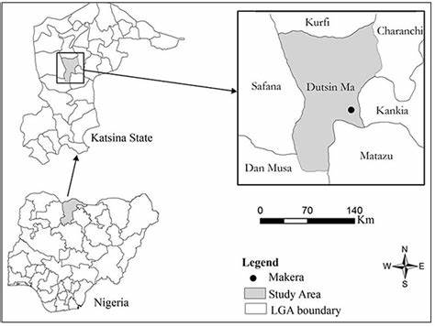

Figure 1.1: Geographical of Map of Nigeria, indicating Katsina state and Dutin-Ma (Oyebamiji *et al*., 2019)

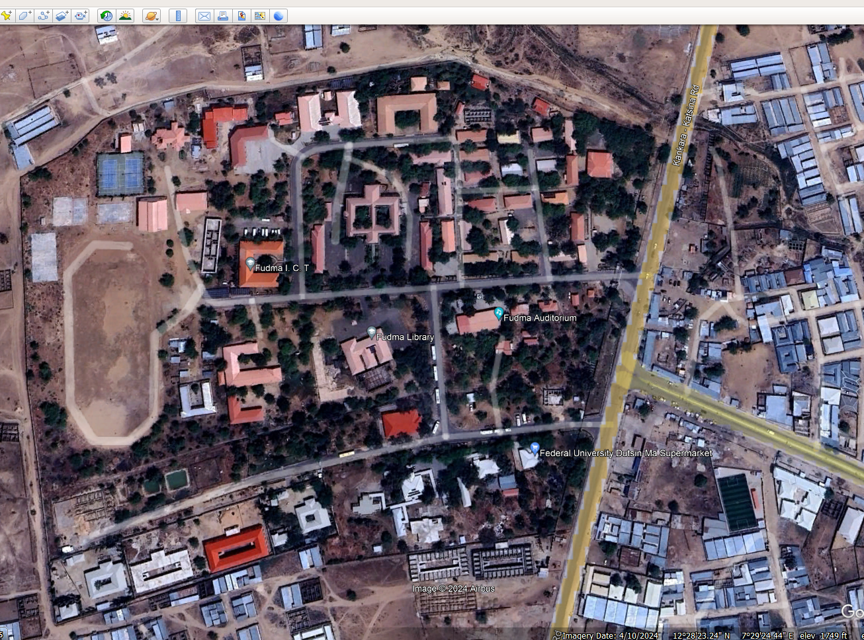

Plate 1: Satellite View of Federal University Dutsin-Ma take-off Campus (Google maps, 2017; modified)

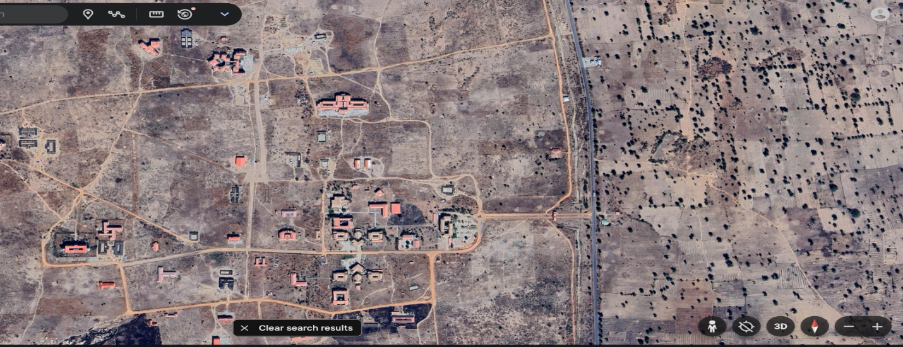

Plate 2: Satellite View of Federal University Dutsin-Ma main Campus (Google maps, 2024; modified)

**Method of measuring terrestrial gamma radiation dose**

The indoor and outdoor ambient terrestrial gamma radiation dose levels at the Federal University Dutsin-Ma take-off and main campuses were measured using a nuclear radiation meter (alert Inspector). 20 locations from each campus were identified where students and staff spend most of their times. For each location, six readings were taken, three indoors and three outdoors. Also, the geographical coordinates of each location monitored were taken with the use of geographical positioning system (GPS).

Prior to the measurements, the radiation meter was calibrated and checked to ensure that it was functioning correctly. The measurement probe was placed at the designated location for a specified time during which the data logger recorded the readings obtained.

From the readings obtained, the annual effective dose (AED), which is the summation of Indoor annual effective dose rate (IAEDR) and Outdoor annual effective dose rate (OAEDR), was calculated as follows (Abba, 2022)

**Annual Effective Dose Equivalent**

$Indoor \left(IAEDR\right):X(mSv/yr)=Y(μSv/hr) X 8760 (hr/yr) X 0.8 X 0.001$ (1)

$Outdoor \left(OAEDR\right):X(mSv/yr)=Z (μSv/hr) X 8760 (hr/yr) X 0.2 X 0.001$ (2)

$AED=IAEDR+OAIDR$ (3)

In eqn. (1) and eqn. (2), above, we converted the indoor and outdoor equivalent doses from micro – Sievert per hour (μSv/h) to milliSievert per year (mSv/y). The annual effective dose equivalent (AED) to the population due to the TGDR was calculated by summing up the IAEDR and OAEDR to the population obtained using eqn. 1 and eqn. 2 above.

**Excess Life Cancer Risk (ELCR) due to TGRD**

The resultant excess life cancer risk due to annual effective dose received estimates the probability of cancer incidence in a population of individuals for a specific lifetime. This was calculated using eqn. (4).(Bello, 2019; Abba, 2022; ICRP, 2007).

$ELCR=AED×LE×RF$ (4)

where LE is the life expectancy and RF the risk factor. In this work, we used the LE value of 55.12 reported by UNPD, 2021 and RF value of 0.057 reported by ICRP, 2007.

**RESULTS AND DISCUSSIONS**

**Results of Terrestrial Gamma Radiation Dose**

Table 1:Take-off campus Area Code, Area locations and geographical coordinates

|  |  |  |  |  |
| --- | --- | --- | --- | --- |
| S-No | Area Code | Area Location | Geographical Coordinates | |
| Latitude | Longitude |
|  | TOC-A1 | School Gate | N12028’20.2” | E007°29’14.0” |
|  | TOC-A2 | Central Mosque | N12°28'23.2” | E007°29'15.2" |
|  | TOC-A3 | Senate Building | N12°28'20.9" | E007°29'09.6" |
|  | TOC-A4 | School Library | N12°28'18.3" | E007°29'09.1" |
|  | TOC-A5 | School Clinic | N12°28'14.8" | E007°29'11.2" |
|  | TOC-A6 | New ICT complex | N12°28'20.6" | E007°29'06.9" |
|  | TOC-A7 | New Physics Lab | N12°28'24.5" | E007°29'10.2" |
|  | TOC-A8 | New Chemistry Lab | N12°28'24.7" | E007°29'10.9" |
|  | TOC-A9 | New Biology Lab | N12°28'24.7" | E007°29'10.5" |
|  | TOC-A10 | Biochemistry Lab | N12°28'22.9" | E007°29'13.1" |
|  | TOC-A11 | Microbiology | N12°28'24.3" | E007°29'14.5" |
|  | TOC-A12 | CBT Lab | N12°28'24.6" | E007°29'07.4" |
|  | TOC-A13 | Students’ Centre | N12°28'16.8" | E007°29'05.3" |
|  | TOC-A14 | Staff School | N12°28'16.2" | E007°29'06.1" |
|  | TOC-A15 | Auditorium | N12°28'19.6" | E007°29'12.4" |
|  | TOC-A16 | Biological Garden | N12°28'25.5" | E007°29'09.7" |
|  | TOC-A17 | Language Lab | N12°28'21.5" | E007°29'15.7" |
|  | TOC-A18 | Girl’s Hostel | N12°28'12.4" | E007°29'03.5" |
|  | TOC-A19 | Soil and Water Lab | N12°28'20.9", | E007°29'11.9" |
|  | TOC-A20 | GIS laboratory | N12°28'21.8" | E007°29'12.8" |

In Table 1 above, we present the Area Codes (unique identifiers), area locations (specific facilities or landmarks), and their corresponding Geographical coordinates (latitude and longitude). The table serves to pinpoint the exact geographical positions of locations on the campus where radiation measurements were conducted. These coordinates are vital for replicating the study, assessing potential environmental or geographical factors influencing radiation levels and integrating radiation data into Geographic information systems (GIS) for spatial analysis. Unique identifiers for each site, labeled as TOC-A1 to TOC-A20, "TOC" stands for Take-off Campus, "A" represents the campus area or location group and numbers indicate specific locations within the campus.

Table 2: Main campus Area Code, Area locations and geographical coordinates

|  |  |  |  |  |
| --- | --- | --- | --- | --- |
| S-No | Area Code | Area Location | Geographical Coordinates | |
| Latitude | Longitude |
|  | MC-A1 | School Gate | N12°17'43.1" | E7°27'.42.0" |
|  | MC-A2 | Senate Building | N12°17'43.3" | E7°27'32.2" |
|  | MC-A3 | ICT Centre | N12°17'40.2" | E7°27'29.4" |
|  | MC-A4 | School Clinic | N12°17'38.7" | E7°27'18.8" |
|  | MC-A5 | University Main Library | N12°17'44.8" | E7°27'25.6" |
|  | MC-A6 | Faculty of Physical Sciences | N12°17'40.9" | E7°27'26.4" |
|  | MC-A7 | Faculty of Life Sciences | N12°17'43.7" | E7°27'25.9" |
|  | MC-A8 | Faculty of Agricultural Sciences | N12°17'37.5" | E7°27'25.7" |
|  | MC-A9 | Faculty of Management Sciences | N12°17'43.3" | E7°27'20.5" |
|  | MC-A10 | Faculty of Nursing Sciences | N12°17'59.8" | E7°27'17.1" |
|  | MC-A11 | Faculty of Health Science | N12°18'01.6" | E7°27'08.3" |
|  | MC-A12 | Faculty of Engineering Sciences | N12°17'54.2" | E7°27'25.2" |
|  | MC-A13 | Faculty of Law | N12°17'41.3" | E7°27'20.4" |
|  | MC-A14 | Entrepreneurship Centre | N12°17'41.0" | E7°27'20.8" |
|  | MC-A15 | Security Unit | N12°17'56.5" | E7°27'43.3" |
|  | MC-A16 | Professorial Building | N12°17'40.2" | E7°27'10.9" |
|  | MC-A17 | Skill G Building | N12°17'44.7" | E7°27'28.2" |
|  | MC-A18 | Female Hostel | N12°17'40.3" | E7°27'02.0" |
|  | MC-A19 | Female Hostel new block | N12°17'42.9" | E7°27'06.1" |
|  | MC-A20 | Male Hostel | N12°17'51.4" | E7°26'55.7" |

Table 2 above provides a comprehensive mapping of 20 identified locations within the main campus, with their corresponding geographical coordinates. These include area codes, area locations, and their precise latitude and longitude values. This table complements the Take-off Campus table (Table1) by providing geospatial data for key locations on the main campus.

Table 3: Descriptive statistical analysis of Take-off and Main campuses result of Indoor and outdoor terrestrial gamma radiation dose.

|  |  |  |  |  |  |  |  |
| --- | --- | --- | --- | --- | --- | --- | --- |
| Area Code | Area Name | INDOOR | OUTDOOR | Area  Code | Area Name | INDOOR | OUTDOOR |
| Average & S. D  (μSv/h) | Average & S. D  (μSv/h) | Average & S. D  (μSv/h) | Average & S. D  (μSv/h) |
| TOC-A1 | School Gate | 0.113±0.01 | 0.13±0.01 | MC-A1 | Gate | 0.173±0.01 | 0.147±0.01 |
| TOC-A2 | Central Mosque | 0.12±0.01 | 0.147±0.01 | MC-A2 | Senate Building | 0.133±0.03 | 0.117±0.01 |
| TOC-A3 | Senate Building | 0.227±0.1 | 0.143±0.02 | MC-A3 | ICT Centre | 0.15±0.03 | 0.127±0.01 |
| TOC-A4 | School Library | 0.233±0.14 | 0.153±0.04 | MC-A4 | School Clinic | 0.34±0.07 | 0.157±0.02 |
| TOC-A5 | School Clinic | 0.35±0.07 | 0.16±0.04 | MC-A5 | University Main Library | 0.21±0.01 | 0.177±0.04 |
| TOC-A6 | New ICT complex | 0.23±0.13 | 0.147±0.02 | MC-A6 | Faculty of Physical Sci | 0.157±0.02 | 0.117±0.01 |
| TOC-A7 | New Physics Lab | 0.13±0.01 | 0.133±0.01 | MC-A7 | Faculty of Life Sciences | 0.243±0.03 | 0.14±0.03 |
| TOC-A8 | New Chem Lab | 0.14±0.02 | 0.157±0.01 | MC-A8 | Faculty of Agriculture | 0.187±0.01 | 0.147±0.01 |
| TOC-A9 | New Biology Lab | 0.183±0.08 | 0.157±0.02 | MC-A9 | Faculty of Management | 0.17±0.02 | 0.177±0.01 |
| TOC-A10 | Biochemistry Lab | 0.237±0.04 | 0.123±0.02 | MC-A10 | Faculty of Nursing | 0.18±0.05 | 0.16±0.02 |
| TOC-A11 | Microbiology | 0.29±0.02 | 0.137±0.03 | MC-A11 | Faculty of Health Sc | 0.163±0.02 | 0.15±0.02 |
| TOC-A12 | CBT Lab | 0.243±0.02 | 0.23±0.01 | MC-A12 | Faculty of Engineering | 0.143±0.01 | 0.17±0.02 |
| TOC-A13 | Students’ Centre | 0.29±0.02 | 0.253±0.03 | MC-A13 | Faculty of Law | 0.173±0.01 | 0.123±0.01 |
| TOC-A14 | Staff School | 0.257±0.01 | 0.137±0.02 | MC-A14 | Entrepreneurship Centre | 0.193±0.02 | 0.19±0.03 |
| TOC-A15 | Auditorium | 0.34±0.06 | 0.143±0.04 | MC-A15 | Security Unit | 0.21±0.01 | 0.173±0.04 |
| TOC-A16 | Biological Garden | 0.143±0.01 | 0.133±0.01 | MC-A16 | Professorial Building | 0.16±0.02 | 0.12±0.01 |
| TOC-A17 | Language Lab | 0.157±0.02 | 0.13±0.01 | MC-A17 | Skill G Building | 0.237±0.01 | 0.19±0.02 |
| TOC-A18 | Girl’s Hostel | 0.227±0.01 | 0.22±0.06 | MC-A18 | Female Hostel | 0.237±0.03 | 0.127±0.01 |
| TOC-A19 | Soil & Water Lab | 0.113±0.01 | 0.147±0.01 | MC-A19 | Female Hostel new block | 0.27±0.04 | 0.123±0.02 |
| TOC-A20 | GIS laboratory | 0.12±0.08 | 0.34±0.09 | MC-A20 | Male Hostel | 0.203±0.01 | 0.143±0.02 |
|  | **MINIMUM** | 0.113 | 0.123 |  | **MINIMUM** | 0.133 | 0.117 |
|  | **MAXIMUM** | 0.35 | 0.34 |  | **MAXIMUM** | 0.34 | 0.19 |
|  | **RANGE** | 0.24 | 0.217 |  | **RANGE** | 0.204 | 0.073 |
|  | **AVERAGE** | 0.211 | 0.174 |  | **AVERAGE** | 0.200 | 0.146 |
|  | **S. D** | 0.076 | 0.0541 |  | **S. D** | 0.049 | 0.024 |
|  | **VARIANCE** | 0.007 | 0.004 |  | **VARIANCE** | 0.004 | 0.001 |
|  | **SKEWNESS** | 0.0146 | 0.813 |  | **SKEWNESS** | -0.170 | -1.495 |
|  | **KURTOSIS** | -0.88 | 4.967 |  | **KURTOSIS** | 2.13 | -1.183 |
|  | **PEARSON** | -0.01 | |  | **PEARSON** | 0.18 | |
|  | **STD ERROR** | 0.0784 | |  | **STD ERROR** | 0.0498 | |

Table 3 above compares indoor and outdoor terrestrial gamma radiation dose levels across the Take-off campus (TOC) and main campus (MC). The table presents measurements of indoor and outdoor terrestrial gamma radiation dose at specific locations within two university campuses. The data includes: Average radiation levels (in micro-sieverts per hour, μSv/hr), Standard deviation (S.D.) representing the variability in measurements for each location. Additionally, the statistical summaries are provided for each campus, including: minimum, maximum, range, average, variance, standard deviation, skewness, kurtosis, Pearson correlation, and standard error. The Area Name describes the specific facilities or regions where radiation measurements were taken. These include: educational facilities (e.g., school library, students’ centre, language lab), administrative or public areas (e.g., gate, senate building, ICT centre), Research and health-related facilities (e.g., Biochemistry lab, New Physics Lab, Clinic), Residential buildings (e.g., Girl’s Hostel, Male Hostel). We observed that the Take-off Campus average indoor level was 0.257 μSv/hr, while the outdoor average was 0.154 μSv/hr. The Indoor radiation levels are consistently higher than outdoor levels. The Skewness (0.014) is near-symmetrical distribution, suggesting balanced values. The Kurtosis has a value of -0.88 showing a flatter distribution with fewer extreme values. The Main campus indoor average was 0.203 μSv/hr while the Outdoor average was 0.148 μSv/hr. The Indoor radiation levels are slightly higher than outdoor levels. The Skewness which was obtained as -0.71 shows negative skewness indicating a concentration of higher indoor values. The Kurtosis (2.13) shows a slightly peaked distribution. Terrestrial gamma radiation levels are influenced by several environmental factors. Soil composition plays a key role since soils rich in uranium-238, thorium-232, and potassium-40 naturally emit more radiation, with variations depending on the local geology. Cosmic radiation also contributes, especially at higher altitudes where the thinner atmosphere offers less protection from high-energy cosmic rays. Additionally, building materials like granite, bricks, and concrete can contain natural radionuclides, increasing indoor radiation exposure. The combination of these factors determines the overall radiation levels in a given area.

Figure 2: Chart of annual effective dose due to terrestrial gamma radiation in take-off campus

The chart in Figure 2, shows the annual effective dose (AED) from terrestrial gamma radiation at various locations in the take-off campus, labeled TOC-A1 to TOC-A20. Values range from 1.02 to 2.76 mSv/year, with TOC-A5 having the highest dose. The average dose (1.75 mSv/year) falls below the world average (2.4 mSv/year) but exceeds the ICRP recommended limit of 1.0 mSv/year. The data highlights localized variations in gamma radiation, emphasizing the need for regular monitoring to ensure safety.

Figure 3: Chart of annual effective dose due to terrestrial gamma radiation in main campus

Figure 3 above, illustrates the annual effective dose (AED) from terrestrial gamma radiation across locations in the main campus, labeled MC-A1 to MC-A20. The values range from 1.14 to 2.64 mSv/year, with MC-A4 recording the highest dose. The average dose (1.67 mSv/y) falls below the world average (2.4 mSv/year) but exceeds the ICRP recommended limit of 1.0 mSv/year. These findings highlight moderate radiation levels, with localized variations across the sites. Continuous monitoring is essential to maintain radiation safety. Reducing exposure to terrestrial gamma radiation requires a mix of practical strategies. Using shielding materials like low-radon concrete, lead-lined walls, and radiation-resistant coatings can help minimize indoor radiation levels. Raising awareness through educational programs ensures people understand the risks and make informed choices about building materials and safe practices. Regular radiation monitoring helps detect any rising levels early, allowing for timely action to protect public health. Combining these efforts can significantly reduce long-term exposure and associated health risks.

Table 4: AED and ELC for both Take-off and Main Campus

|  |  |  |  |  |  |
| --- | --- | --- | --- | --- | --- |
| **Area Code** | **AED (TOC) (mSv/y)** | **ELCR (TOC)** | **Area code** | **AED (MC)**  **(mSv/y)** | **ELCR (MC)** |
| TOC-A1 | 1.02 | 3.21 | MC-A1 | 1.47 | 4.62 |
| TOC-A2 | 1.09 | 3.46 | MC-A2 | 1.14 | 3.59 |
| TOC-A3 | 1.84 | 5.79 | MC-A3 | 1.27 | 4.01 |
| TOC-A4 | 1.90 | 5.98 | MC-A4 | 2.64 | 8.3 |
| TOC-A5 | 2.76 | 8.68 | MC-A5 | 1.78 | 5.61 |
| TOC-A6 | 1.87 | 5.88 | MC-A6 | 1.31 | 4.11 |
| TOC-A7 | 1.14 | 3.61 | MC-A7 | 1.95 | 6.13 |
| TOC-A8 | 1.25 | 3.96 | MC-A8 | 1.57 | 4.93 |
| TOC-A9 | 1.55 | 4.9 | MC-A9 | 1.50 | 4.72 |
| TOC-A10 | 1.87 | 5.9 | MC-A10 | 1.54 | 4.85 |
| TOC-A11 | 2.27 | 7.15 | MC-A11 | 1.41 | 4.42 |
| TOC-A12 | 2.10 | 6.62 | MC-A12 | 1.29 | 4.07 |
| TOC-A13 | 2.47 | 7.79 | MC-A13 | 1.42 | 4.49 |
| TOC-A14 | 2.04 | 6.42 | MC-A14 | 1.68 | 5.3 |
| TOC-A15 | 2.65 | 8.35 | MC-A15 | 1.77 | 5.58 |
| TOC-A16 | 1.23 | 3.89 | MC-A16 | 1.33 | 4.19 |
| TOC-A17 | 1.32 | 4.18 | MC-A17 | 1.99 | 6.26 |
| TOC-A18 | 1.97 | 6.22 | MC-A18 | 1.88 | 5.92 |
| TOC-A19 | 1.05 | 3.3 | MC-A19 | 2.11 | 6.63 |
| TOC-A20 | 1.43 | 4.52 | MC-A20 | 1.67 | 5.26 |
| **MINIMUM** | 1.02 | 3.21 | **MINIMUM** | 1.14 | 3.59 |
| **MAXIMUM** | 2.76 | 8.68 | **MAXIMUM** | 2.64 | 8.3 |
| **RANGE** | 1.73 | 5.47 | **RANGE** | 1.50 | 4.72 |
| **AVERAGE** | 1.75 | 5.49 | **AVERAGE** | 1.64 | 5.15 |
| **WORLD AVERAGE** | 2.40 | 2.80 | **WORLD AVERAGE** | 2.40 | 2.80 |

Table 5: Correlation between Take-off and Main Campus AED

|  |  |  |
| --- | --- | --- |
|  | *AED TOC (mSv/y)* | *AED MC (mSv/y)* |
| AED TOC (mSv/y) | 1 |  |
| AED MC (mSv/y) | 0.325070332 | 1 |

Table 6: Correlation between Take-off and Main Campus ELCR

|  |  |  |
| --- | --- | --- |
|  | *ELCR (MC)* | *ELCR (TOC)* |
| ELCR (MC) | 1 |  |
| ELCR (TOC) | 0.347731885 | 1 |

The correlation between AED TOC and AED MC in Table 6 is 0.3251, which means there’s a weak positive relationship. In simple terms, when AED increases at one campus, there’s a slight tendency for it to increase at the other but not always. This suggests that while both locations might share some common environmental influences, like natural background radiation, local factors play a bigger role in determining the actual dose levels. Similarly, the correlation between ELCR TOC and ELCR MC in Table 6 is 0.3477, which is also a weak positive correlation. Since ELCR is calculated from AED, it makes sense that the two would have a somewhat similar pattern. But again, the relationship isn’t strong, meaning other factors like variations in water consumption, shielding effects, or local geological differences could be affecting cancer risk estimates at each campus independently. So overall, while there’s a bit of a connection between radiation exposure and risk levels at TOC and MC, they’re mostly shaped by their own unique environmental conditions.

The statistical analysis reveals a **weak positive correlation** between the **Annual Effective Dose (AED)** and **Excess Lifetime Cancer Risk (ELCR)** at the Take-off Campus (TOC) and Main Campus (MC). The correlation coefficients (0.3251 for AED and 0.3477 for ELCR) suggest a weak positive relationship, indicating that while radiation exposure levels and associated cancer risks at both campuses share some similarities, they are largely influenced by independent environmental factors.

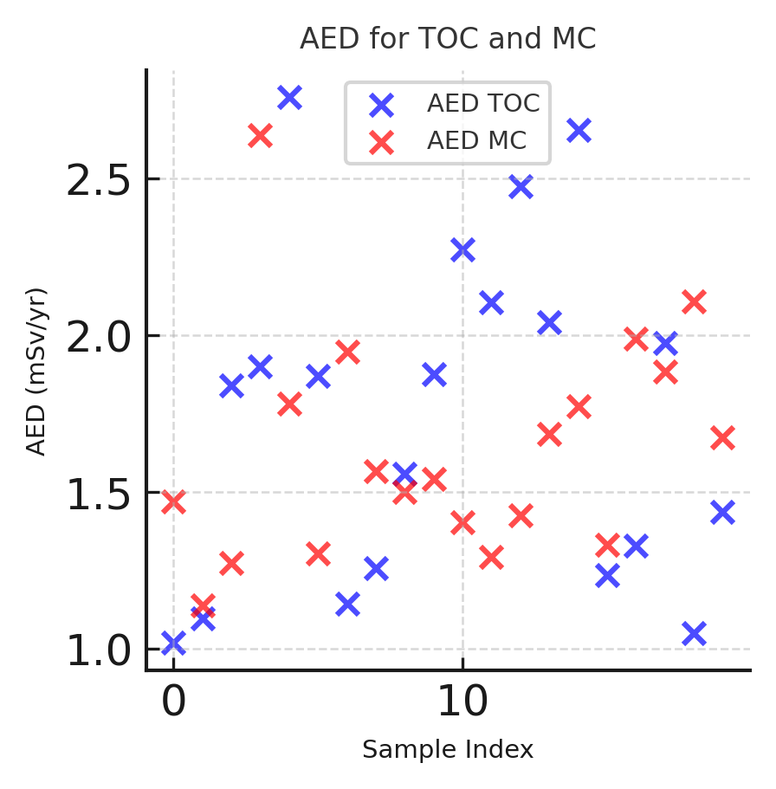

Figure 4: Scatted plots correlation for annual effective dose (AES) in take-off and main campus

The scatter plot comparing AED for TOC and MC shows a weak positive correlation, suggesting slight similarities in radiation exposure at both campuses. However, variations indicate local environmental differences. The spread of points confirms that AED levels are not strongly dependent on each other, requiring site-specific radiological assessments.

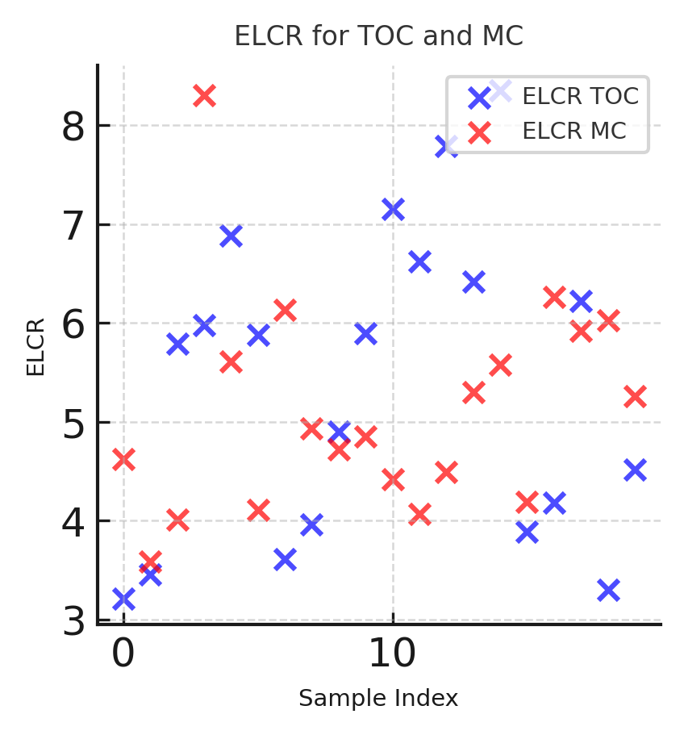

Figure 5: Scatted plots correlation for excess lifetime cancer risk (ELCR) in take-off and main campus

The ELCR scatter plot reveals a weak correlation between TOC and MC, meaning lifetime cancer risk estimates slightly relate but vary independently. Differences in local exposure conditions likely influence ELCR values. This suggests that risk assessments should be conducted separately for each campus, considering unique environmental and radiological factors.

**CONCLUSION**

This work investigates the radiological nature of Federal University Dutsin-Ma take-off and Main campuses. Digital Radiation Meter was used to measure terrestrial gamma radiation and corresponding annual effective dose was numerically computed along with excess life cancer risk (ELCR). Annual effective dose (AED) which is the total annual effective dose combining both indoor and outdoor exposures, highest AED was the school clinic (TOC-A5) with a value of 2.76 mSv/y, due to higher indoor and outdoor dose rates compared to other locations. Lowest AED was the school gate (TOC-A1) with 1.02 mSv/y, attributed to lower dose rates indoors and outdoors. Average AED of take-off campus was 1.75 mSv/y, which provides a baseline for exposure levels across all sampled areas. A minimum of 1.02 mSv/y and a maximum of 2.76 mSv/y. In the main campus, the school clinic (MC-A4) has the highest AED of 2.64 mSv/y, indicating significantly elevated radiation levels compared to other locations. Lowest AED was the senate building which was 1.14 mSv/y, attributed to lower indoor and outdoor dose rates. The campus-wide average AED is 1.64 mSv/y, slightly lower than the take-off campus average. The statistical analysis reveals a **weak positive correlation** between the **Annual Effective Dose (AED)** and **Excess Lifetime Cancer Risk (ELCR)** at the Take-off Campus (TOC) and Main Campus (MC). The correlation coefficients (0.3251 for AED and 0.3477 for ELCR) suggest that while the radiation exposure levels and associated cancer risks at both campuses are somewhat related, they are not strongly dependent on each other. Radiation exposure thresholds are set to minimize health risks, with the ICRP-recommended public dose limit of 1 mSv/year and higher occupational limits for radiation workers. Long-term exposure above these thresholds increases the likelihood of biological effects, including DNA damage, cell mutations, and a heightened risk of cancer. Studies like those from UNSCEAR (2021) report have shown a direct correlation between increased radiation dose and cancer risk, even at low doses. Epidemiological research on atomic bomb survivors and occupational radiation workers further supports these findings, emphasizing the importance of keeping exposure as low as reasonably achievable (ALARA). Several studies have assessed terrestrial gamma radiation exposure in university environments, highlighting variations in dose levels and potential health risks. A survey at the University of Port Harcourt, Nigeria, found that most indoor radiation levels were below the 1 mSv/year safety limit, except for a pharmaceutical laboratory with slightly elevated levels (Ononugbo and Ishiekwene, 2017). Similarly, a study in Minna, Nigeria, reported gamma dose rates between 0.125 and 0.184 µSv/hr, with an average annual dose of 0.189 mSv/year, well below the ICRP recommended limit (Ajayi & Ajayi, 2010). In Dhaka, Bangladesh, research at the Atomic Energy Centre Dhaka (AECD) recorded an average annual effective dose of 0.472 mSv/year, aligning with global averages (Hossain *et al*., 2017). However, a follow-up study found indoor dose rates ranging from 0.373 to 0.646 µGy/hr, with annual effective doses reaching up to 3.17 mSv/year, suggesting the need for monitoring and mitigation (International Journal of Scientific Research and Management, 2017). These findings emphasize the importance of regular radiation assessments in university environments to ensure safe exposure levels for students and staff.

**REFERENCES**

Abba, L. (2022). Assessment of the health and environmental impacts due to radionuclides and heavy metals depositions around Sokoto cement company, Nigeria. (Unpublished Doctoral thesis). ABU Zaria, Nigeria.

Ahmed, N. K. and El-Arabi, A. G. M., (2005). Natural radioactivity in farm soil and phosphate fertilizer and its environmental upper Egypt. *Journal of Environmental Radioactivity,* pp. 51 - 64.

Aliyu, A. B., Lawal, H. I., Sadiq, M. A., Umar, I. M., & Umar, A. A. (2023). Uranium and thorium contaminations of baobab leaves consumed in Katsina State, Nigeria. *Journal of Basic and Applied Scientific Research, 13*(4), 56–64. Retrieved from https://www.ajol.info/index.php/jobasr/article/view/288721

Bello, S. (2019). Assessment of health hazards associated with environmental radioactivity and heavy metals contamination around Shanono and Bagwai gold mines, Kano state (Unpublished Doctoral thesis). ABU Zaria, Nigeria.

Chad-Umoren, Y. E.; Adekanmbi, M. & Harry, S. O. (2007). Evaluation of Indoor Background Ionizing Radiation Profile of a Physics Laboratory. *Facta Universitatis Series: Working and Living Environmental Protection,* 3(1): 1-7.

Farai, I. P. and Vincent, U. E. (2006). Outdoor Radiation Level Measurement in Abeokuta, Nigeria. *Nigeria Journals of Physics*, 18(1), 121-126.

Google Maps (2017). Satellite Image of Federal University Dutsin-Ma (modified). [www.googlemaps.com/](http://www.googlemaps.com/)Dutsin-ma, Retrieved on 27 January, 2023.

Hossain, S., Rahman, M. S., Islam, M. A., & Ahsan, M. H. (2017). Measurement of indoor terrestrial gamma radiation dose and evaluation of annual effective dose at AECD Campus, Dhaka, Bangladesh. *International Journal of Scientific Research and Management, 5*(3). <https://doi.org/10.18535/ijsrm/v5i3.11>

IAEA., (2007). International Atomic Energy Agency. Safety and Security (n.d). Retrieved from https://www.iaea.org

ICRP. (2007). 2006 Recommendations of the International Commission on Radiological Protection, ICRP Publication 103, Pergamon Press, Oxford. 69-72

Jaishankar, M. (2014). Toxicity, mechanism and health effects of some heavy metals. *Interdisciplinary Toxicology,* 7(2), pp. 60-72.

James, I. U, Moses, I. F, Vandi, J. N, and Ikoh U. E (2015). Measurement of Indoor and Outdoor Background Ionising Radiation Levels of Kwali General Hospital, Abuja. *Journal of Applied Science and Environmental Management*, 19 (1): 89 – 93.

Jwanbot, D. I, Izam, M. M., Nyam, G. G., and Yusuf, M. (2014). Indoor and Outdoor Gamma Dose Rate Exposure Levels in Major Commercial Building Materials Distribution Outlets in Jos, Plateau State-Nigeria. *Asian Review of Environmental and Earth Sciences*, 1(1): 5-7.

Kovalchuk, I., Kovalchuk, O. and Hohn, B., (2001). Biomonitoring the genotoxicity of environmental factors with transgenic plants. *Trends in plant science,* 6(7), pp. 306310.

Masok, F. B., Dawan, R. R. and Mangset, W. E. (2015). Assessment of Indoor and Outdoor Background radiation Levels in Plateau State University, Bokkos, Jos, Nigeria. *IISTE Journal of Environmental and Earth Sciences*, 5(8), 1-4.

Ochiai, E. (2014). *Juniata College.* [Online] Available at: <https://www.juniata.edu/offices/juniatavoices/media/ochiai-radiation.pdf> [Accessed 23 01 2018].

Olarinoye, I. O., Sharifat, I., Baba-Kutigi, A., Kolo, M. T., & Aladeniyi, K. (2010). Measurement of background gamma radiation levels at two tertiary institutions in Minna, Nigeria. *Journal of Applied Sciences and Environmental Management, 14*(1), 55–58. Retrieved from <https://www.ajol.info/index.php/jasem/article/view/56491>

Ononugbo, C. P., & Ishiekwene, M. (2017). A survey of environmental radioactivity levels in science laboratories of Abuja Campus, University of Port Harcourt, Nigeria. *Archives of Current Research International, 9*(3), 1–10. <https://doi.org/10.9734/ACRI/2017/35912>

Osiga, A. D. (2014). Radiation Level Measurement in Delta State University, Campus III, Abraka, Nigeria. *Science-African Journal of Scientific Issues, Research and Essays*, 2 (11): 503-517.

Oyebamiji, N. A., G. Y. Jamala, and D. O. Adelani. (2019). Effects of agroforestry trees biomass and urea on maize tasselling and silking production. *World Scientific News* 120.2: 250-258.

Pöschl, M. and Nollet, L. M. L., (2007). *Radionuclide Concentrations in Food and the Environment,* Boca Raton: Taylor and Francis Group.

Tikyaa, E. V., Atsue, T. and Adegboyega, J. (2017). Assessment of the ambient background radiation levels at the take-off campus of federal university Dutsin-ma, Katsina state-Nigeria. *FUDMA Journal of Sciences (FJS) Maiden Edition Vol. 1 No. 1, November, 2017, pp 58-68*

UNSCEAR (2021). United Nations Scientific Committee on the Effects of Atomic Radiation (UNSCEAR). *Sources, effects and risks of ionizing radiation: UNSCEAR 2020/2021 Report to the General Assembly, with scientific annexes.* United Nations. Retrieved from <https://www.unscear.org/unscear/en/publications/scientific-reports.html>

UNSCEAR. (2000). Sources and effects of ionizing radiation report to the general assembly with scientific annexes. United Nations Scientific Committee on the Effect of Atomic Radiation, New York.

USEPA (2011). Recommended Use of BW3/4 as the Default Method in Derivation of the Oral Reference Dose. EPA/100/R11/001. Office of the Science Advisor, USA. <http://www.epa.gov/raf/publications/pdfs/recommended-use-of-bw34.pdf>

WHO (2003). World Health Organization Guidelines for drinking water quality. Health Criteria and Other Information, Geneva.